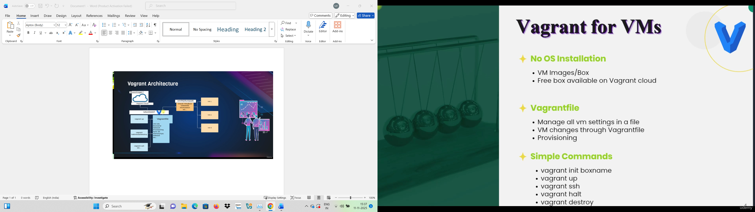

1. Vagrant init <box path>
2. Once downloaded
3. Vagrant box list - the box image
4. Vagrant status – to check box is running or not
5. Vagrant global-status – to check of other VMs
6. Vagrant global-status –prune – will clear other VM which are not part of vagrant
7. Vagrant up – start machine
8. Vagrant ssh – to connect to machine shell
9. Vagrant halt – to shutdown
10. Vagrant sudo -i – switch to root user
11. Vagrant reload – reboot if any changes done in machine
12. Vagrant destroy - delete vm baox